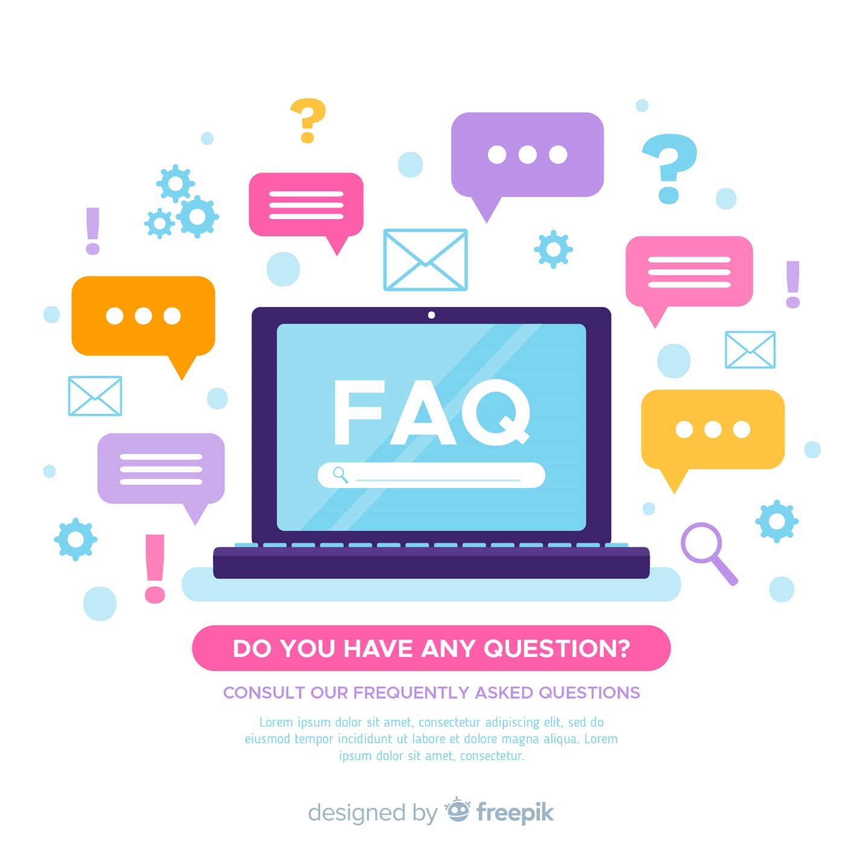

CHECK OUT OUR ANSWERS TO YOUR MOST COMMONLY ASKED QUESTIONS!